***Chapter 2.***

**Project Management**

**2.1PROJECT PLANNING AND SCHEDULING**

**2.1.1 Project Development Approach:-**

## Objective:

The objectives under this stage are to:

* Evaluate the overall project development approach systems including appropriate management systems and timeline for implementation (See Project Delivery)
* Evaluate potential project development approaches. The project development approach should comprise procedures that document the management functions and envisaged phase gate system of approach to the project
* Evaluating the requirements in terms of quality systems and procurement mechanisms (See Project Delivery)

## Major Deliverables

The major deliverables under this stage are:

* Evaluation of the most appropriate project management strategy to ensure delivery of project against key success criteria (see Project Context and Definition)
* Evaluation of procurement model options for the major transport facilities and associated plant infrastructure (see Project Delivery)
* Evaluation to ensure the correct project approach dependent on transport facility design, specific location, regulatory requirements and financial plan (see Project Context and Definition)

## Tasks

The major tasks under this stage include:

* Evaluation of potential management team structures, considering key areas of team required:
* Project Manager
* Engineering Team
* Commercial Team
* Environmental Team
* Legal and Financial
* Stakeholder management
* Programme management

**2.1.2 ProcessModel:-**

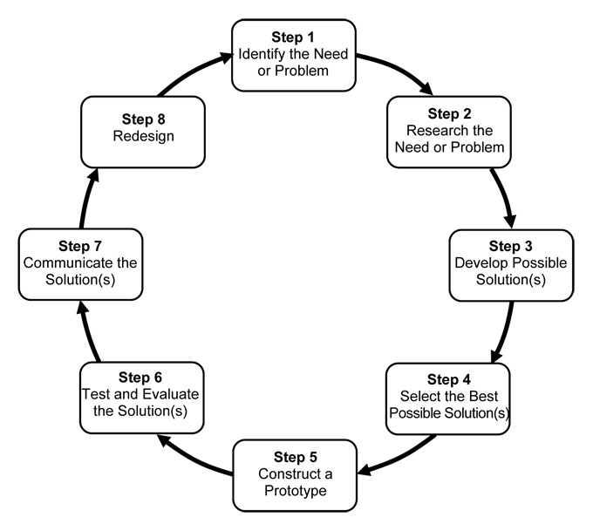

**Roles &Responsibilities:-**

|  |  |
| --- | --- |
| **RESPONSIBILITIES** | **ROLES** |
| Analysis | Vidita, Riya |
| Design | Riya |
| Coding | Vidita |
| Front-siteDesign | Vidita, Riya |
| Testing | Vidita, Riya |
| Documentation | Vidita, Riya |

**2.1.3 Schedule Representation:-**

|  |  |  |
| --- | --- | --- |
| Description | Estimate ddays | Actual Days |
| System Study | 8 | 15 |
| Requirement Gathering | 8 | 7 |
| Analysis | 8 | 12 |
| System Design | 15 | 20 |
| Coding | 40 | 30 |
| Testing | 10 | 30 |

**(*Schedule Project Working Days*)**















**2.2. Risk Management**

Risk analysis and manage men tane a series of step that help as of ware team to understand and manage uncertainty. Many problems can plugs use software project. A risk is a potential problem–it might happen, it might not .But, regardless so the outcomes , its really good idea to identify it, assess its probability of occurrence ,estimate its impact, and stash contingency plan should the problem occur.

Software is difficult under taking. Lots of things can go wrong, many often do. It’s or this reason that being prepared–understanding the risks and talking proactive measures to a void or manage them–is a key element of good software project management. Different step sin risk analysis and manage mentare Risk Identification ,Risk Analysis and Risk Planning& Management.

**2.2.1. Risk Identification**

Risk identification is the first stage of risk management .It is concern with discovering possible risks to the project. In principal, these should not be assess priority data this stage, although in practice risks with very min or consequence or very low probability risk are not usually considered.

**Dependencies**

• Availability of trained, experienced people

•Inter communing printer -group dependencies

• Customer-furnished items or information

•Internal and external sub contractor relationship

**Requirement Issues**

•Lack of clear product vision

•Lack of agreement on product requirement

• Technical staff conflict

•Un prioritized requirements

•New market with uncertain nee

            •Rapidly changing requirements

            •In adequate impact analysis of requirements changes

**Management Issues**

•Inadequate planning and task identification

•Inadequate visibility into actual project status

•Un clear project owner ship and decision-making

•Unrealistic commitments made, sometimes for the wrong reasons

•Managers or customers with unrealistic expectations

•Staff personality conflicts

•Poor communication

|  |  |  |
| --- | --- | --- |
| **Risks** | **RiskType** | **Description** |
| Technology | Business | Theunderlyingtechnology  on which the system is builtis superseded bynew technology. |
| Requirement  Change | ProjectandProduct | Therewillbealargerno.  ofchangesto the requirements than anticipated. |
| Hardware  unavailability | Project | Hardwarethatisessential  totheprojectwillnotbe delivered onschedule. |
| Specification  Delay | Project and Product | Specification of essential  Interface are not available on schedule |
| Size under  Estimated | Project and Product | The size of the systemis  under estimated |

**2.2.2 Risk Analysis:-**

➢When risks are an analysis it is import an quantify the level of un certainty and the degree of loss associated with each risk. To accomplish this, different categories of risks are considered.

• **Project Risks:-** threat the project plan. That is, if project risks become real, it is likely that projects schedules will slip and that costs will increase. Project risks identify potential budgetary, schedule , personnel,(staffing and organization),resources ,customer and requirements and their impaction software project. There are many factors like project complexity, size, and the degree of structural uncertainty were also define project (and estimation), risk factors

.

• **Technical Risks:-**threat en the quality and time lines of the of ware to be produce technical risk become reality, implementations may become difficult or impossible and maintenance problems. In additions, specifications ambiguity, technical un certainty, technical obsolescence and“ leading -edge” technology are also risk actors. Technical risks occur because the problem is hard so then we thought it would be.

• **Business Risks:-** threaten the viability of the software to be built. Business risks often jeopardize the projector the product. Can did for the top five business risks are(1)building excellent product or system that no one really wants(market risk),(2)building a product that no longer fits into the overall businessstrategyforthecompany(strategicrisk),(3)buildingaproductthat the sales force doesn’t understand how to sell,(4)losing the support of senior management due to change in focus or change in people(management risk),and(5)losing budgetary or personnel commitment(budget risks).It is extremely important to not that simple categorization won’t always work. Some risks are simple unpredictable in advance.

• Anothergeneralcategorizationofriskshasbeenproposed.Knownrisksare those that can be uncovered after careful evolution of the project plan, the business and technical environment in which the project is being developed, and other reliable information sources. Un predictable risks are the deck ok. They can and do occur, but they are extremely difficult to identify in advances.

**2.2.3 Risk Planning:-**

Here is how we deal with all the above said risks:

• **Technological Risk:** to avoid this risk, I planned that use JavaScript whenever it must be required and avoid ding use of flash.

• **Economical Risk:** there is on to solve economical risk. Because there is no problem about economical problem.

• **Political Risk:** permitting of the organization to display or advertisement information is solves this problem.

**2.3 ESTIMATION:-**

**2.3.1 Effort Estimation:-**

➢Development in such applications requires programming skills and sound knowledge in the v b .net with various others function laities and tools used with it.

**2.3.2. Cost Analysis:-**

➢The cost spent in the making of the project is categorized into two parts:

**A)Direct cost:** This is in terms on money.

In our project it is the estimated cost of:

•Hardware (Laptop)

•Software (Dreamweaver)

•Documentation Cost.

**B) Indirect cost:** This is in terms of lab our or the manual work.

In our project it is the estimated cost in terms of:

•Times pent in system analysis and design

•Managing time for coding.

•Generating Report

•Referring others ounces like the internet.